Input: The input is given in the format shown below:
Ex:

S->aSa|bSb|a|b|e

S is start symbol {a,b} denote the terminal symbols and ‘e ’ denotes epsilon.

Output: The output is given in the following format:
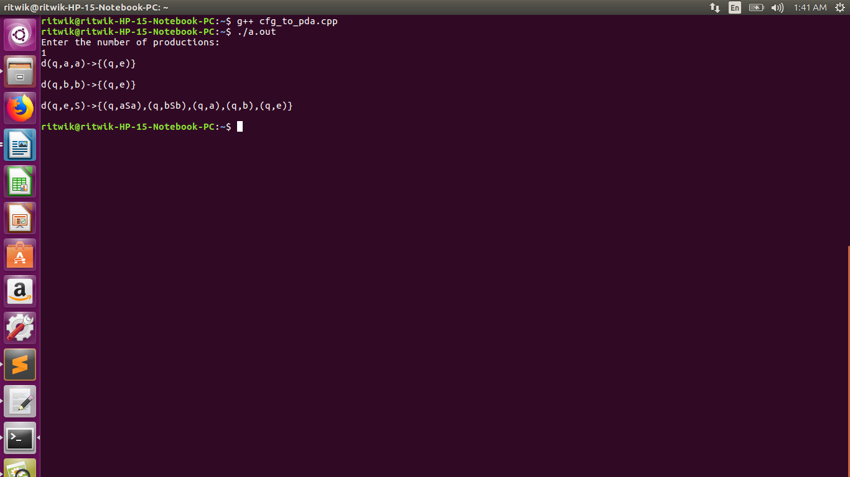
The program prints the transitions of the pda in standard format.

Code:

I have used a map to store the transitions of the pda.

Ex: S->aSa Here index of map is q,e,S where q denotes the state ‘e’ denotes input symbol and ‘S’ denotes top of stack . And value is q,aSa for the transition.

Thus the transition is:

d( q,e,S )-> (q,aSa )

Similarly done for all productions.

Lastly added the transitions for the non-terminal symbols i.e ‘a’ and ‘b’
d(q,a,a)->(q,e)
d(q,b,b)->(q,e)

